**Aditya Sureka**

**C 47 SEM 3**

**DS**

**Experiment no 5**

**Aim:** To implement Circular Queue ADT using array

**Objective:**

Circular Queue offer a quick and clean way to store FIFIO data with maximum size

Theory: A Circular Queue is an extended version of a normal queue where the last element of the queue is connected to the first element of the queue forming a circle. The operations are performed based on FIFO (First In First Out) principle. In a normal Queue, we can insert elements until the queue becomes full. But once the queue becomes full, we can not insert the next element even if there is a space in front of the queue.

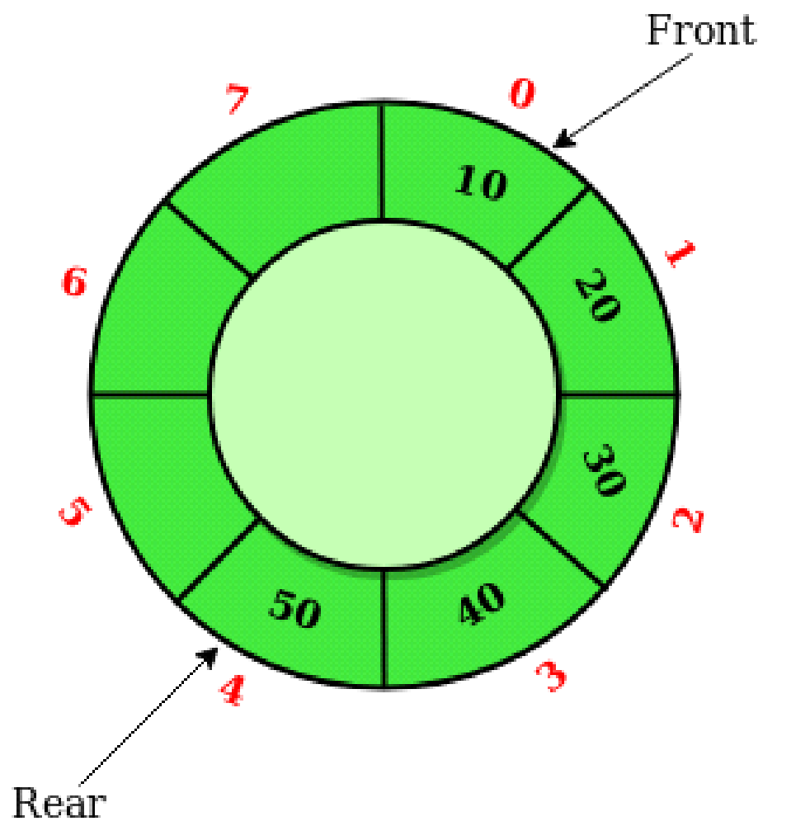

**Algorithm:**

* INIT(QUEUE,FRONT,REAR,COUNT)
* INSERT-ITEM(QUEUE, FRONT, REAR, MAX, COUNT, ITEM)
* REMOVE-ITEM(QUEUE, FRONT, REAR, COUNT, ITEM)
* FULL-CHECK(QUEUE,FRONT,REAR,MAX,COUNT,FULL)
* EMPTY-CHECK(QUEUE,FRONT,REAR,MAX,COUNT,EMPTY)

INIT(QUEUE,FRONT,REAR,COUNT)

This algorithm is used to initialize a circular queue.

1. FRONT := 1;

2. REAR := 0;

3. COUNT := 0;

4. Return;

INSERT-ITEM( QUEUE, FRONT, REAR, MAX, COUNT, ITEM)

This algorithm is used to insert or add item

into a circular queue.

1. If ( COUNT = MAX ) then

a. Display “Queue overflow”;

b. Return;

2. Otherwise

a. If ( REAR = MAX ) then

i. REAR := 1;

b. Otherwise

i. REAR := REAR + 1;

c. QUEUE(REAR) := ITEM;

d. COUNT := COUNT + 1;

3. Return;

REMOVE-ITEM( QUEUE, FRONT, REAR, COUNT, ITEM)

This algorithm is used to remove or delete item

from the circular queue.

1. If ( COUNT = 0 ) then

a. Display “Queue underflow”;

b. Return;

2. Otherwise

a. ITEM := QUEUE(FRONT)l

b. If ( FRONT =MAX ) then

i. FRONT := 1;

c. Otherwise

i. FRONT := FRONT + 1;

d. COUNT := COUNT + 1;

3. Return;

EMPTY-CHECK(QUEUE,FRONT,REAR,MAX,COUNT,EMPTY)

This is used to check if the queue is empty or not.

1. If( COUNT = 0 ) then

a. EMPTY := true;

2. Otherwise

a. EMPTY := false;

3. Return ;

FULL-CHECK(QUEUE,FRONT,REAR,MAX,COUNT,FULL)

This algorithm is used to check if the queue is full or not.

1. If ( COUNT = MAX ) then

a. FULL := true;

2. Otherwise

a. FULL := false;

3. Return ;

**Circular Queue implementation in C:**

#include <stdio.h>

#define SIZE 5

int items[SIZE];

int front = -1, rear = -1;

// Check if the queue is full

int isFull() {

if ((front == rear + 1) || (front == 0 && rear == SIZE - 1)) return 1;

return 0;

}

// Check if the queue is empty

int isEmpty() {

if (front == -1) return 1;

return 0;

}

// Adding an element

void enQueue(int element) {

if (isFull())

printf("\n Queue is full!! \n");

else {

if (front == -1) front = 0;

rear = (rear + 1) % SIZE;

items[rear] = element;

printf("\n Inserted -> %d", element);

}

}

// Removing an element

int deQueue() {

int element;

if (isEmpty()) {

printf("\n Queue is empty !! \n");

return (-1);

} else {

element = items[front];

if (front == rear) {

front = -1;

rear = -1;

}

// Q has only one element, so we reset the

// queue after dequeuing it. ?

else {

front = (front + 1) % SIZE;

}

printf("\n Deleted element -> %d \n", element);

return (element);

}

}

// Display the queue

void display() {

int i;

if (isEmpty())

printf(" \n Empty Queue\n");

else {

printf("\n Front -> %d ", front);

printf("\n Items -> ");

for (i = front; i != rear; i = (i + 1) % SIZE) {

printf("%d ", items[i]);

}

printf("%d ", items[i]);

printf("\n Rear -> %d \n", rear);

}

}

int main() {

// Fails because front = -1

deQueue();

enQueue(1);

enQueue(2);

enQueue(3);

enQueue(4);

enQueue(5);

// Fails to enqueue because front == 0 && rear == SIZE - 1

enQueue(6);

display();

deQueue();

display();

enQueue(7);

display();

// Fails to enqueue because front == rear + 1

enQueue(8);

return 0;

}

**Output:**

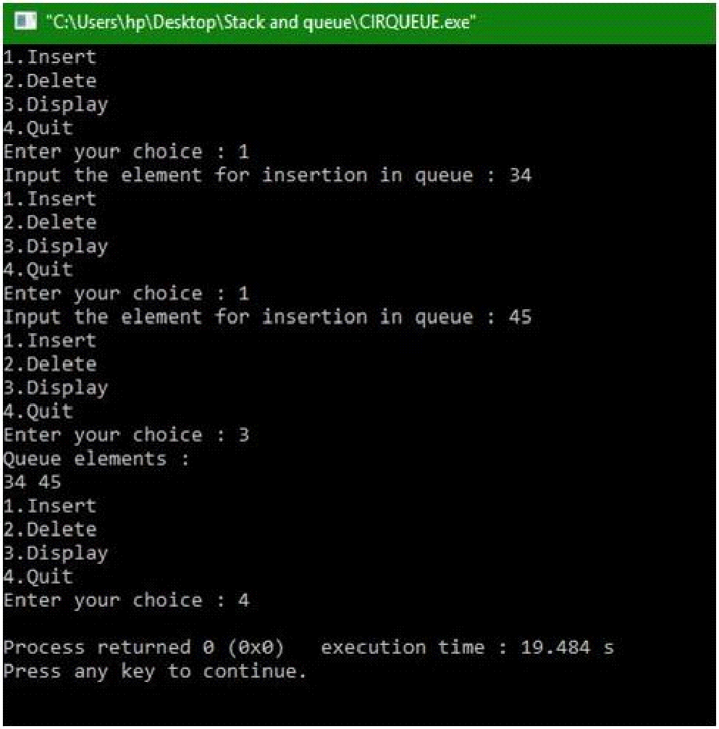

**Conclusion:**

The Circular Queue is similar to a Linear Queue in the sense that it follows the FIFO (First In First Out) principle but differs in the fact that the last position is connected to the first position, replicating a circle.